Contents
Internal Document Numbering for Admin Documents 2
Emails as PDFs 3
Only final deliverables in Admin/17-Deliverables 4
QUAL Forms 5

Internal Document Numbering for Admin Documents
Please follow internal document numbering procedures (QUAL3130 - Exhibit A-3 - Admin File Naming Convention [p. 14]). Per Attachment A, 102:
This quality assurance procedure is primarily concerned with the management of administrative files. For additional instruction on the management and naming of CAD files, refer to the current version of the National CAD Standards (NCS) or other applicable corporate project production (PRJP series) documents. Client requirements for specific file naming conventions or folder structures must always be followed.

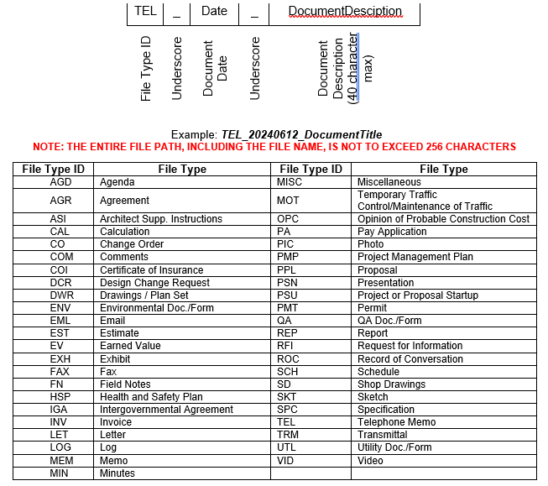
Figure 1Valid File Types and naming per QUAL3130

Emails as PDFs
Per QUAL3130 6.3.1 Digital Records [p. 6])
As a minimum, all digital records, including email furnished to the client or other outside parties as project deliverables or project communications, are to be converted by project staff to portable document format (PDF) to maintain retrievability over the retention period.Other digital records, including email, are to be converted to PDF if retrievability over the retention period is a project requirement or the records are of potential future value to Hanson.
This does not apply to converting native files in MS office, or other file types that cannot be converted to a PDF – Clarification for Industry Staff only. All native files must be saved to same location as the email PDF.
This modifies QUAL3130.6.3.1 requirements and approval is being sought by Corporate QA.
This functionality should be built-in to your Outlook. If you do not have it, forward me the message and I will save it for you.
Please save email attachments in the same directory as the Email PDF.
From Reading View:
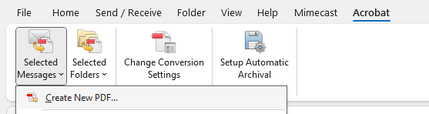
Figure 2Saving Email as PDF from Outlook, Reading View

From Email View:

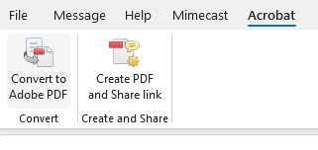
Figure 3Saving Email as PDF from Outlook, Email view

Only final deliverables in Admin/17-Deliverables
The 17-Deliverables folder shall only contain documents transmitted officially to or from Client in final native and PDF format. This directory is not a staging directory and shall not be used as such. Please use the other Admin/CAD Subject folders, respectively. No additional Subject folders may be created within Admin without Project Manager approval.
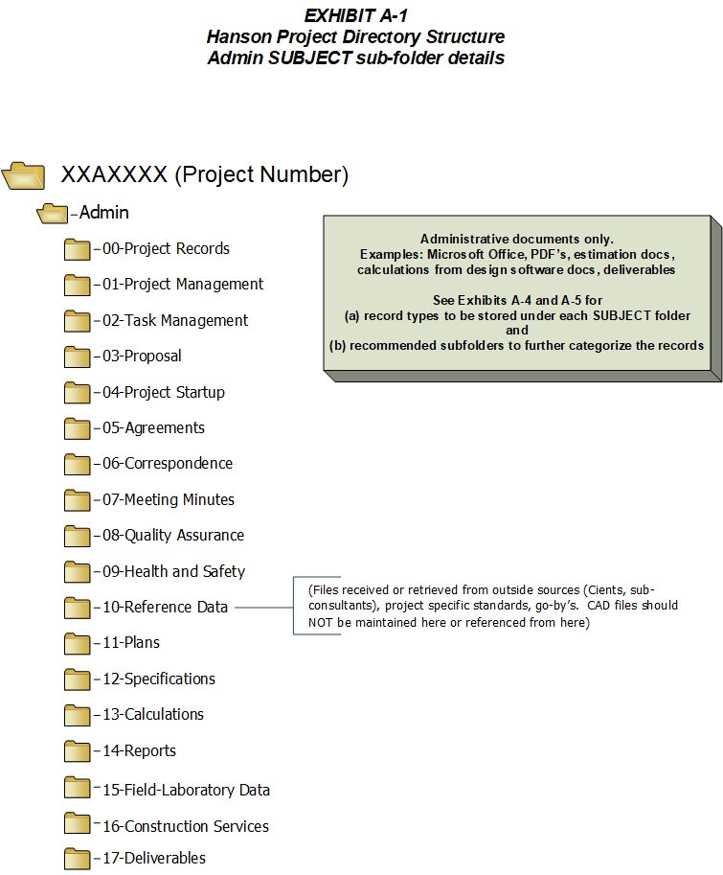
Figure 4Project's Admin directory structure

QUAL Forms
As many of you are aware, deliverables require an associated QUAL form per their respective QUAL procedure (i.e., technical calculations which fall under QUAL3090 shall have an associated QUAL3090.01 form).
Quality Assurance Documents
Furthermore, Originator (O) is assigned to create the document and distribute to Task Manager(s) (TM) [Reviewer(s)] in sequential order with the QUAL form. Once all TMs have reviewed Originator sends deliverable with QUAL form to Professional of Record (POR) [Approver].

Once a deliverable is approved by POR, O sends deliverable to Client or to Hanson Document Control, if available, and stores deliverable (native and PDF) and QUAL form in ./Admin/17-Deliverables.

Term Relationships between industry-standard and Hanson
Hanson Terminology | industry-standard Terminology
Originator | Originator
Task Manager | Reviewer
Professional of Record | Approver

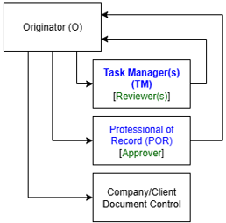
QUAL form must match revision block of the deliverable.

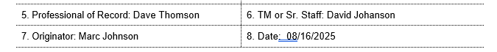
Figure 5QUAL Form O, TM, and POR
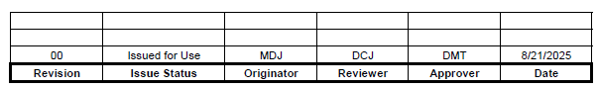
Figure 6Revision Block Originator, Reviewer, and Approver

